Mathematics:

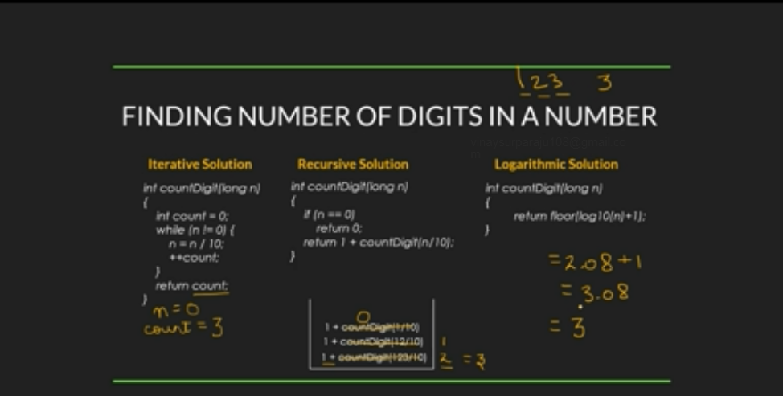

AP:

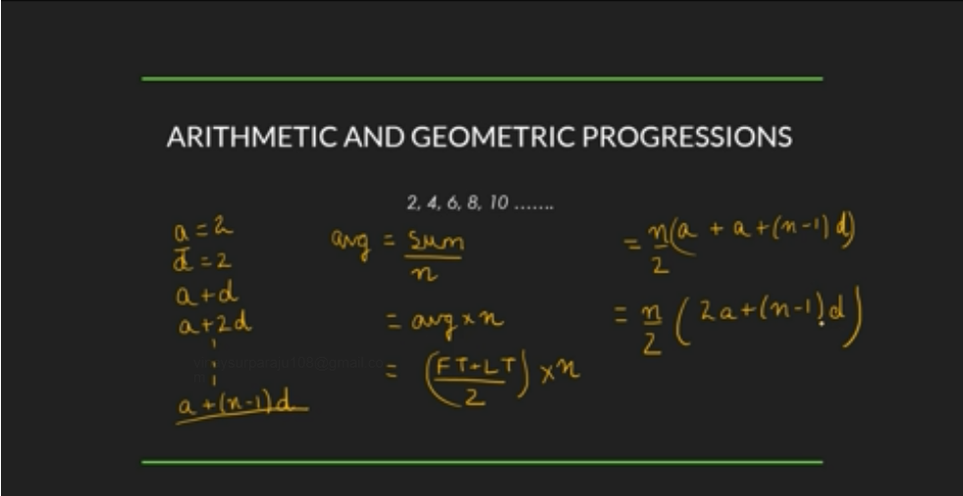

GP:

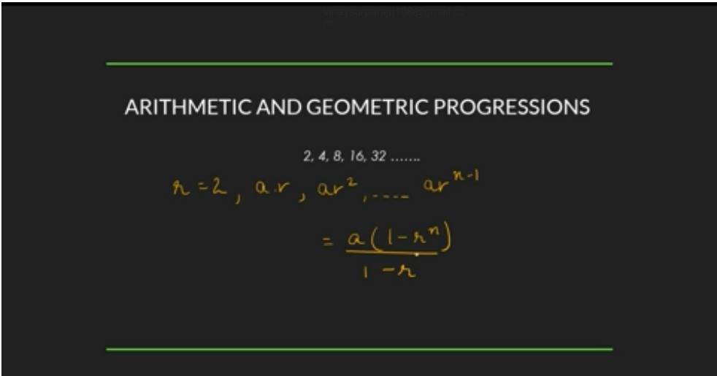

Quadratic:

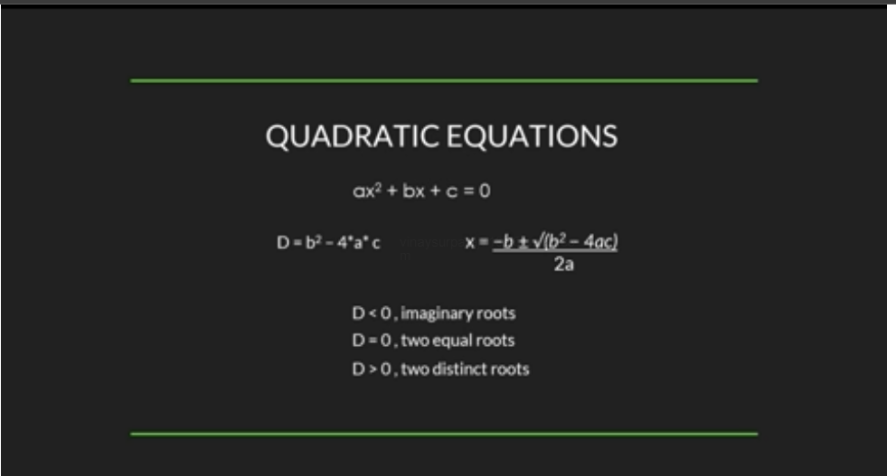

Mean and Median:

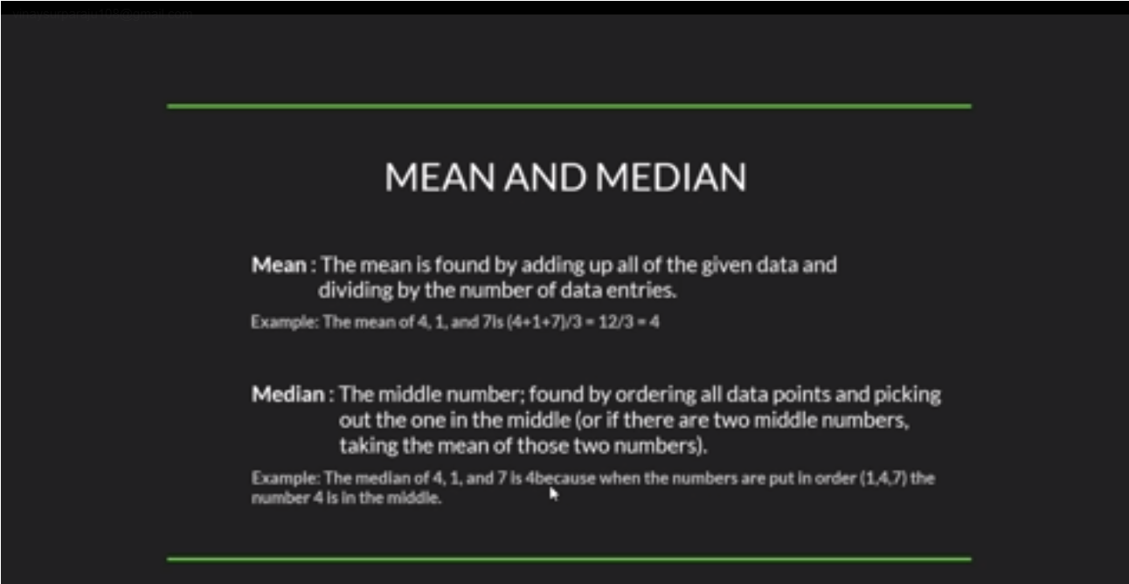

Prime numbers:



LCM and HCF:

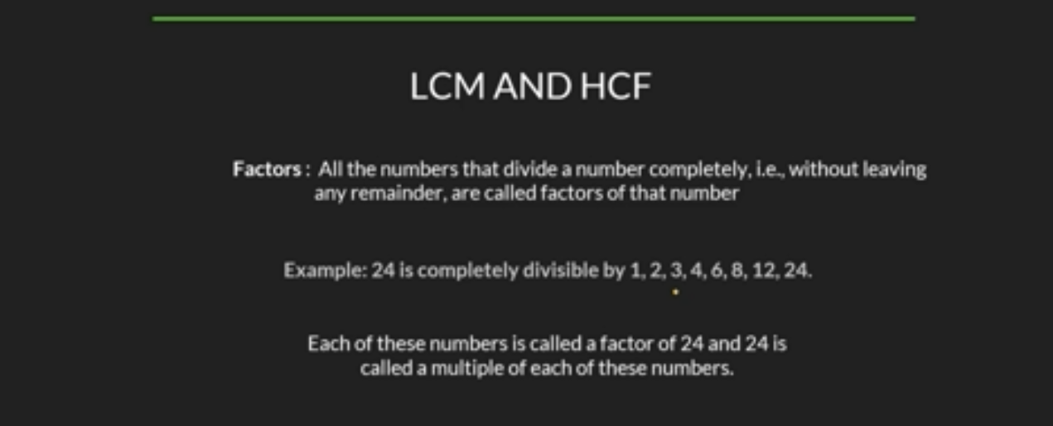

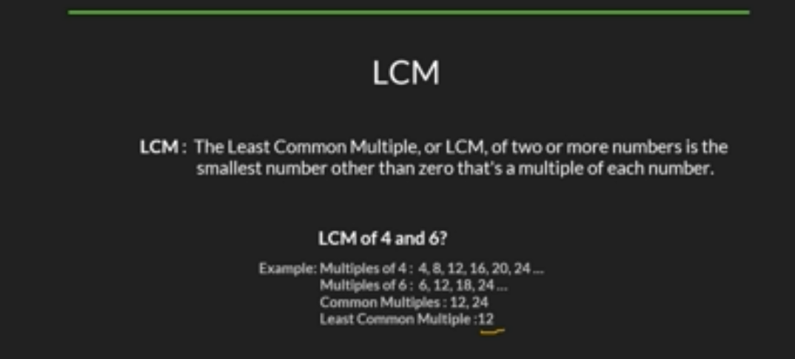

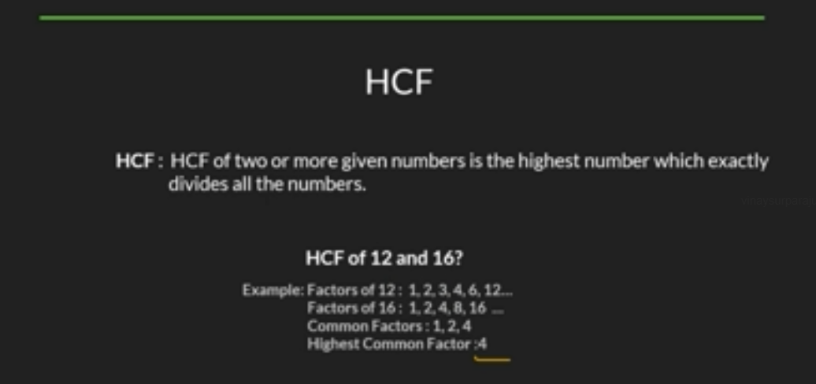

Factorials:

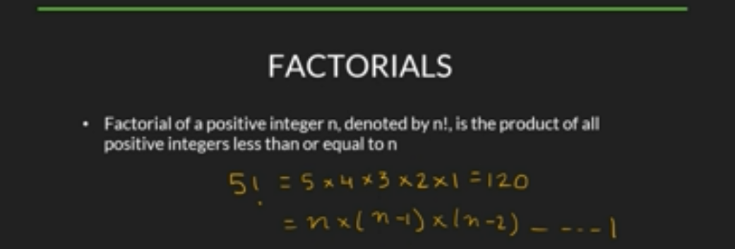

Permutation and combination:

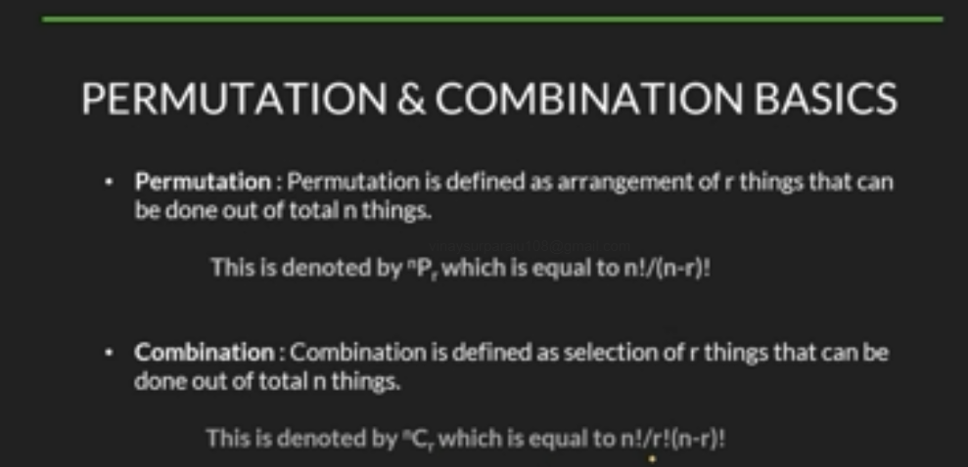

Modular arithmetic:

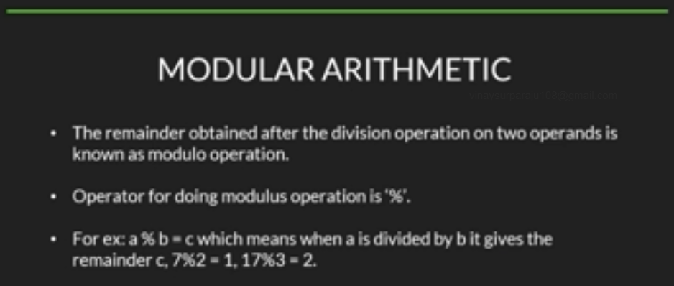

Count Digits:

The below iterative program takes theta(n) times with respect to time complexity

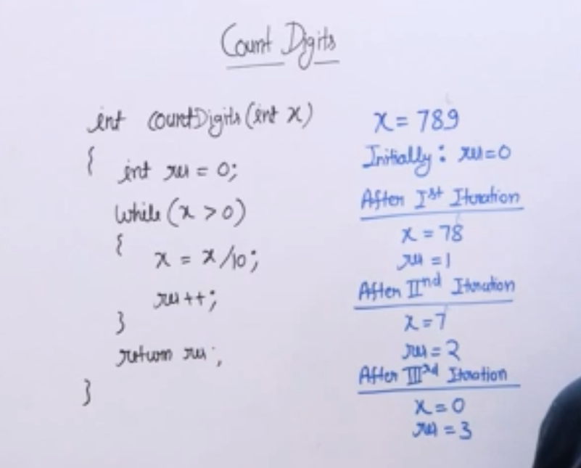

Palindrome:

A number is a palindrome if its reverse is same as input number.

A single digit number is always a palindrome number.

Idea: Traverse digits from right to left to find reverse of a given number

Last digit= x%10 will give the last digit

Remainder = x/10 will give remainder.

rev = rev\*10+last digit where rev is initialized to 0

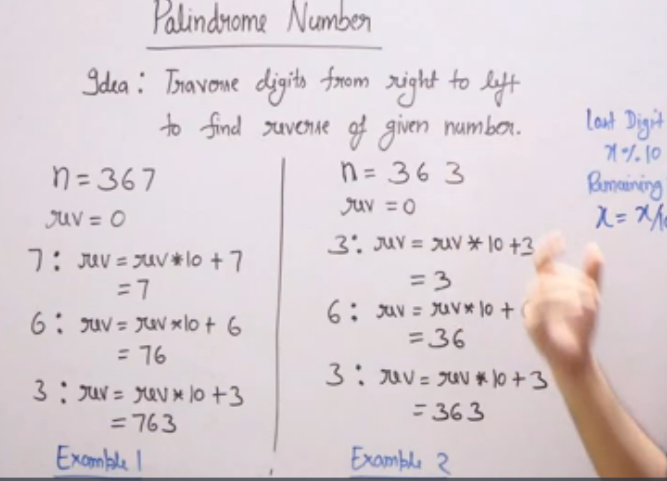

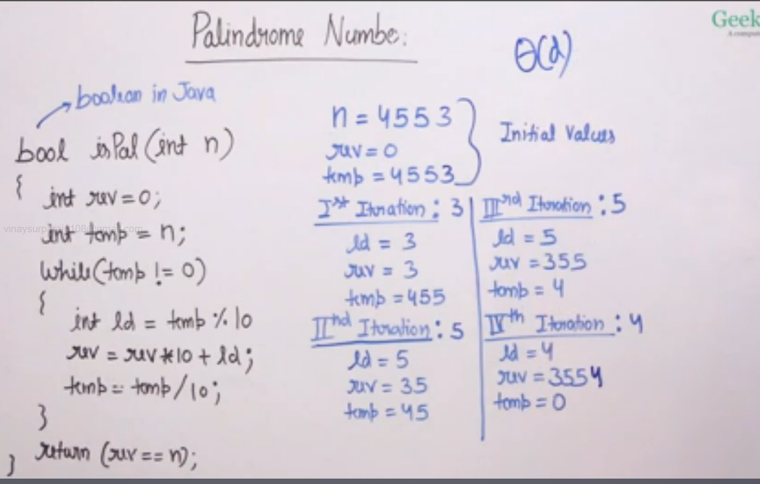

Factorial of number:

Factorial is defined for input >= 0 and it is multiplication of all numbers from 1 to n.

Iterative sol

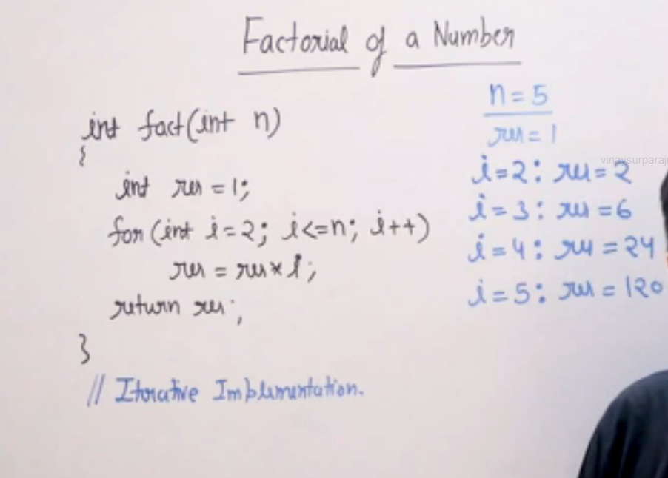

Fact approach:

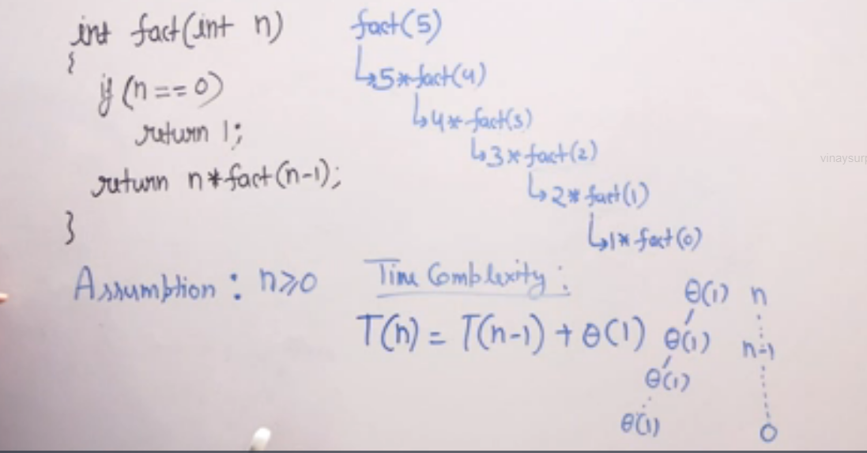

Iterative approach is better with respect to space complexity

=====================================================================================

Trailing zeros in factorial:

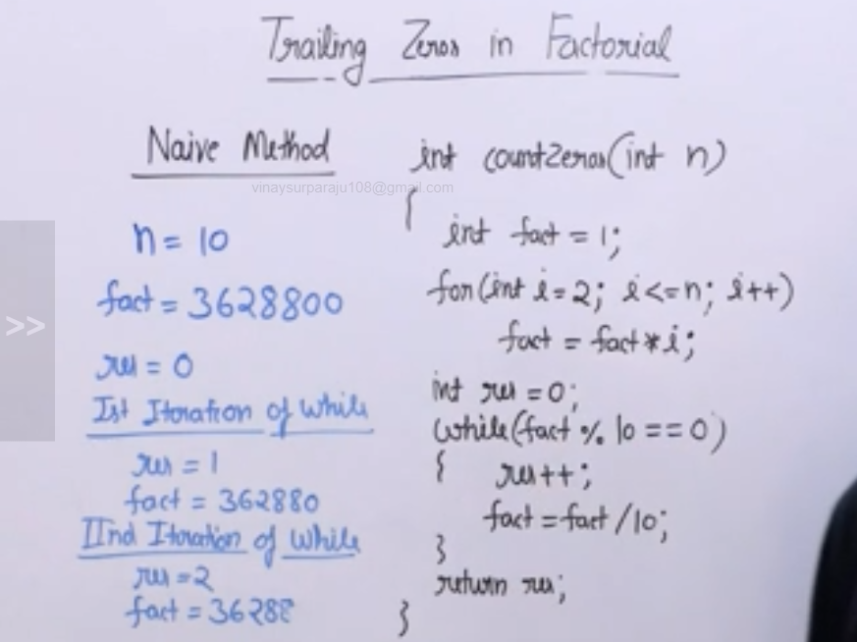

The above approach has an issue with overflow, bcoz for fact 20, we will have 19 digits and we may not have datatype to store the value for large numbers

Efficient method –

By using 5 prime factorization

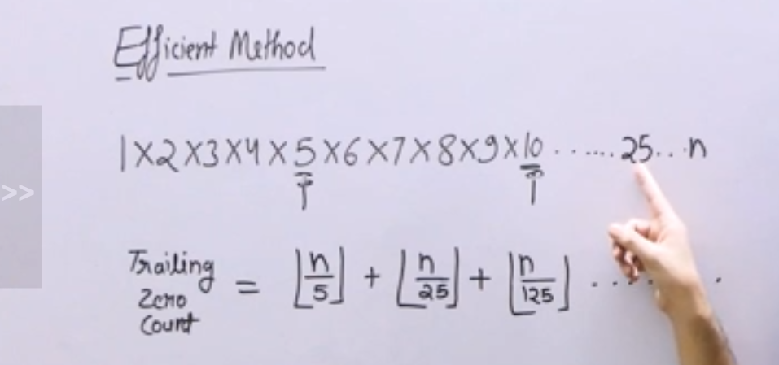

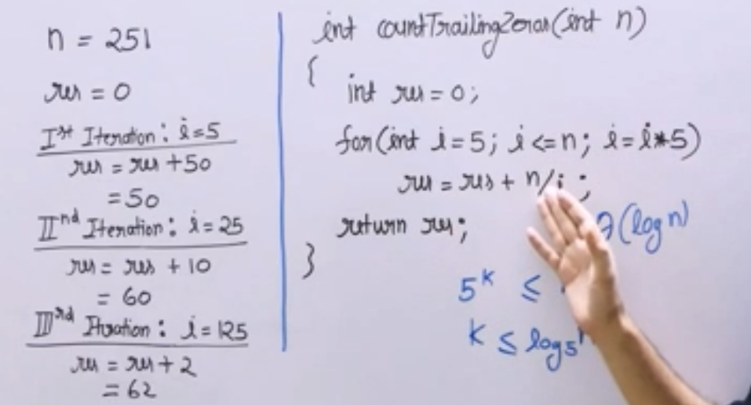

GCD or HCF of a number:(Greatest common divisor)

If one number divides other big number then HCF of those two number is the number.eg 100, 200, HCF is 100

Please note, if two numbers does not have common divisor then the numbers need not be prime. Eg 9,10, HCF is 1

1. Naive sol –

The max GCD of 2 input numbers can be min of those 2 numbers

Then we try to divide the two input numbers with min of number,if both the input numbers divide equally then we have GCD, else we decrement the number and repeat the process until both the numbers are divide with a common factor.

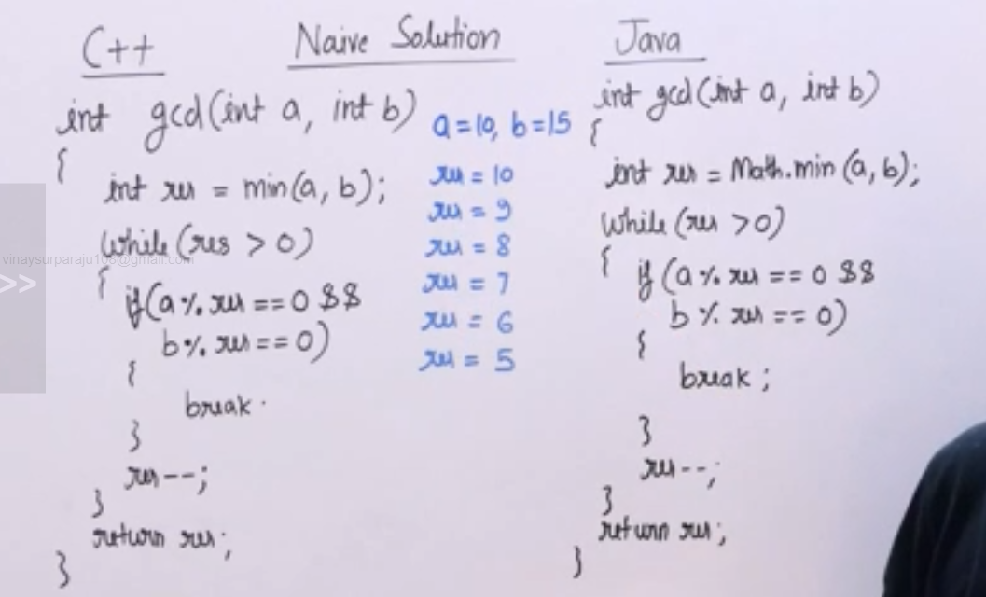

Time complexity for above approach is Theta(min(a,b)

1. Euclid algorithm approach:

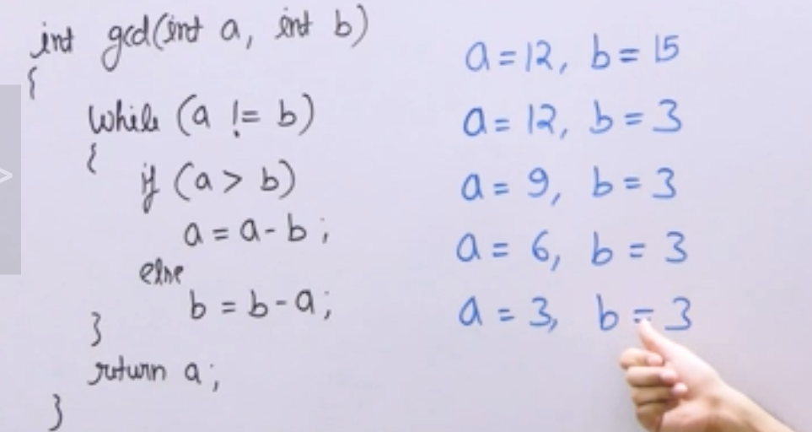

Optimized approach:

In x%y if x is < y then the result will always be x.

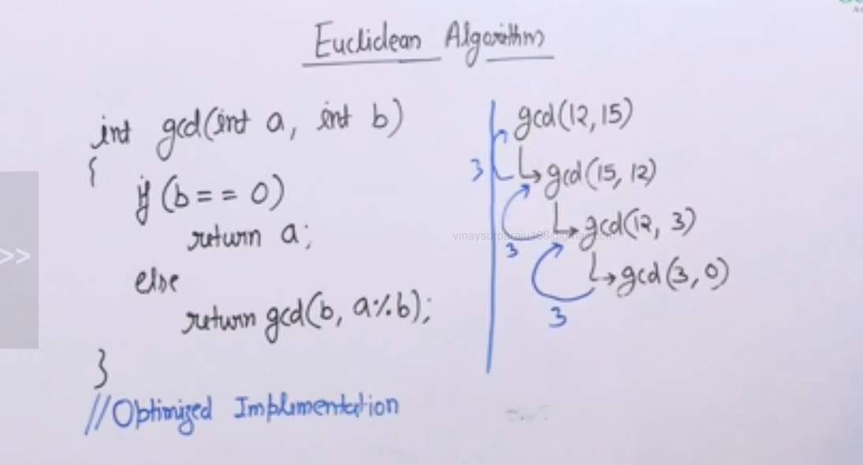

LCM of numbers:(Least common multiple) -

LCM of two numbers is max of those two input numbers.

If two numbers are co-prime, then LCM is the product of those two numbers.

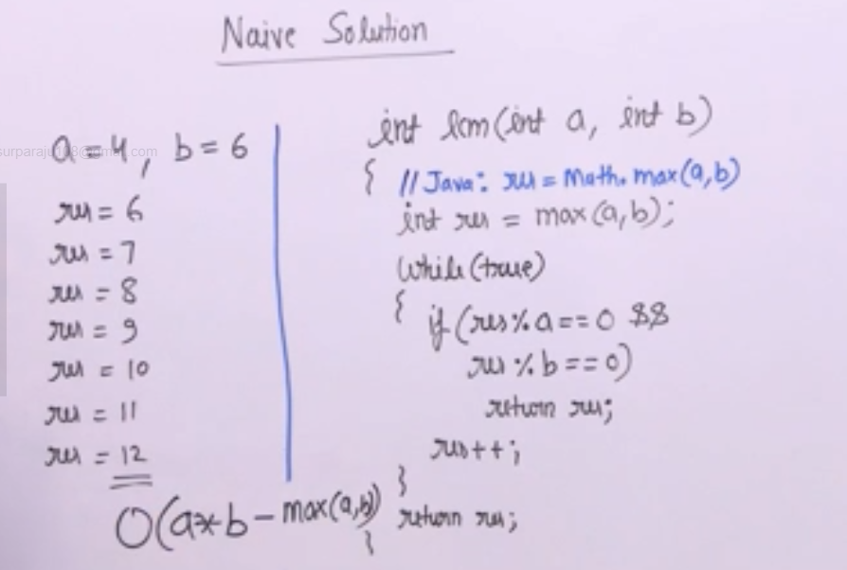

Efficient approach:

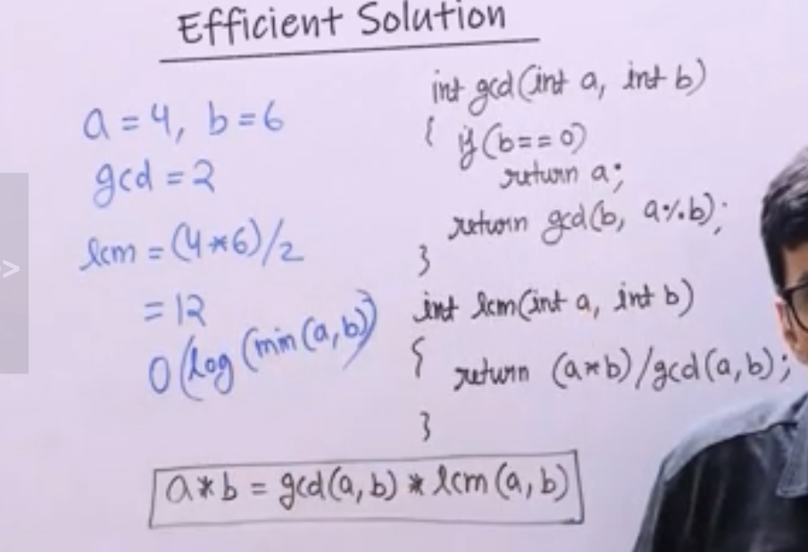

Prime numbers:

A number is said to be prime, if it is divisible by itself or 1

Naïve method: To check for prime n, from 2 to n-1

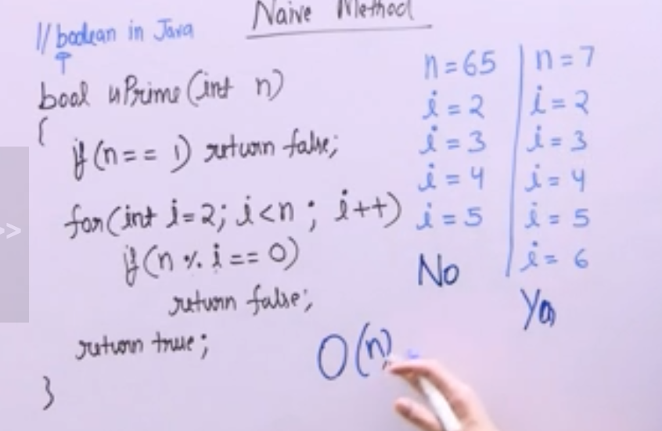

Efficient method:

Divisors always appear in pairs

To check for prime n, from 2 to sqrt(n).Even if there is a divisor greater than sqrt(n), it will have pairs and will be less than sqrt(n)

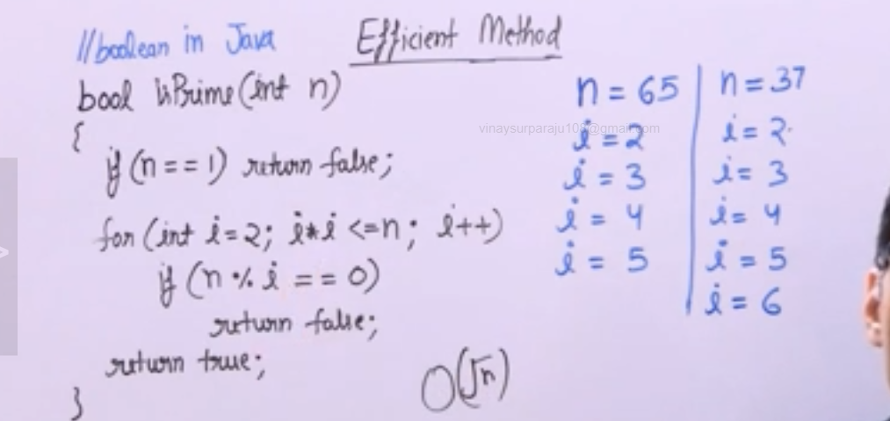

More efficient sol:

If n is large, then sqrt(n) can also be a big number

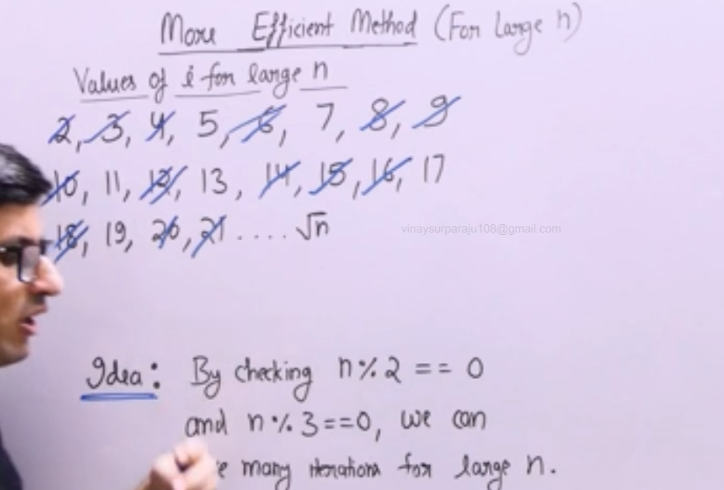

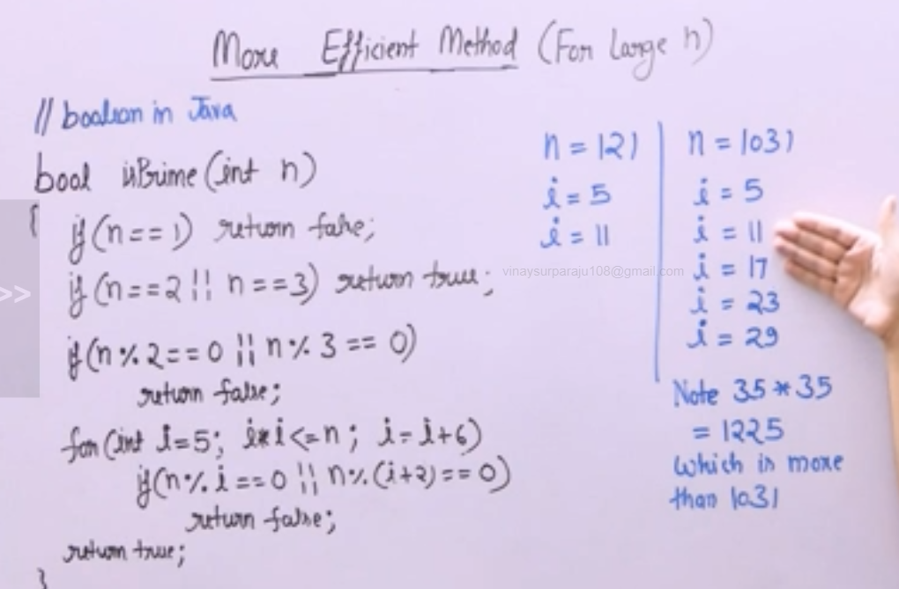

Prime Factors:

When prime factors are multiplied it gives the original number

Naïve approach:

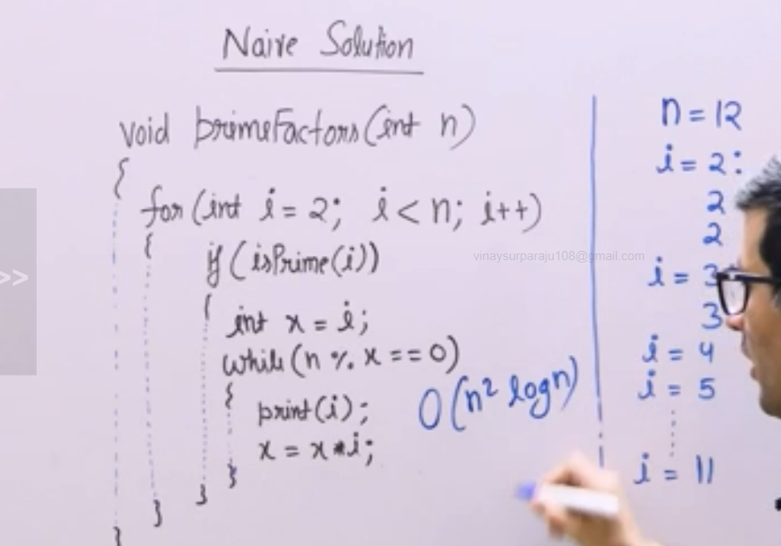

Efficient approach:

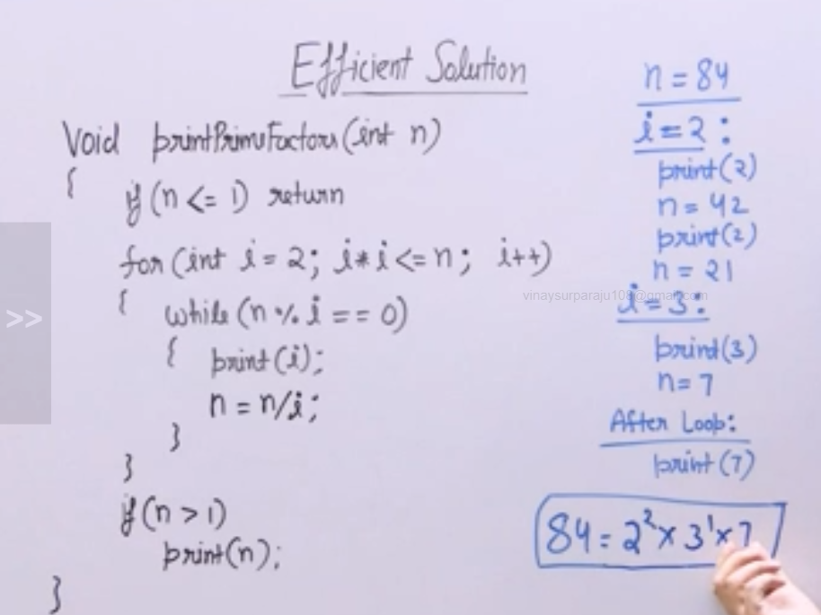

More eff approach:

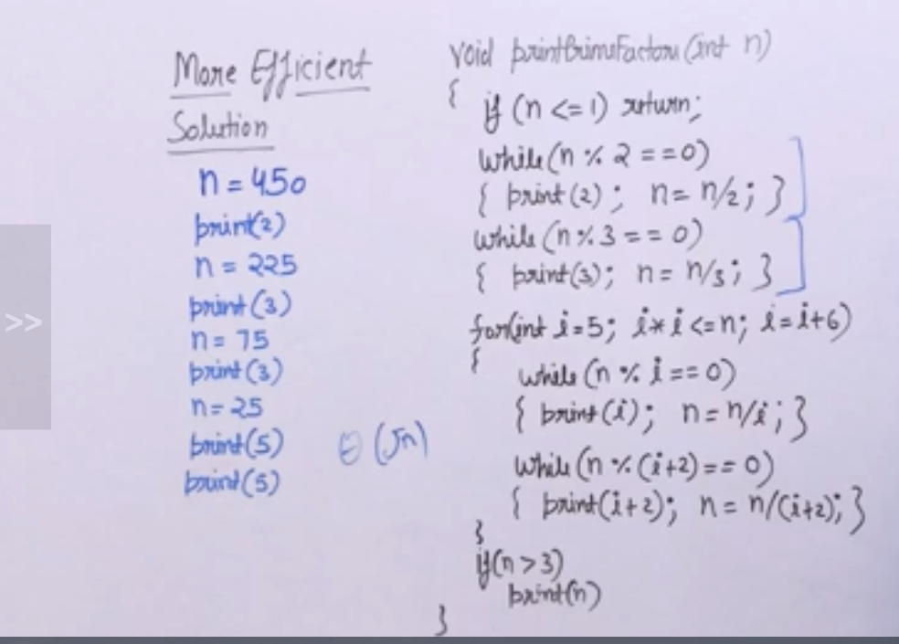

Divisors of number:

Naïve approach –

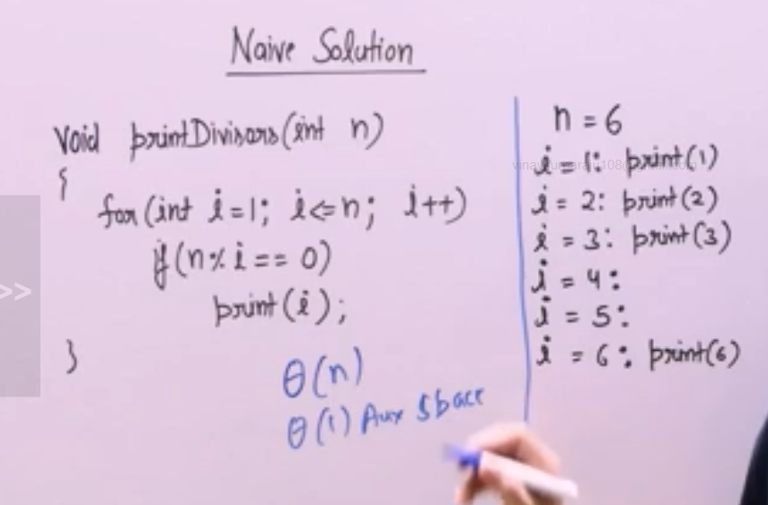

Efficient approach:

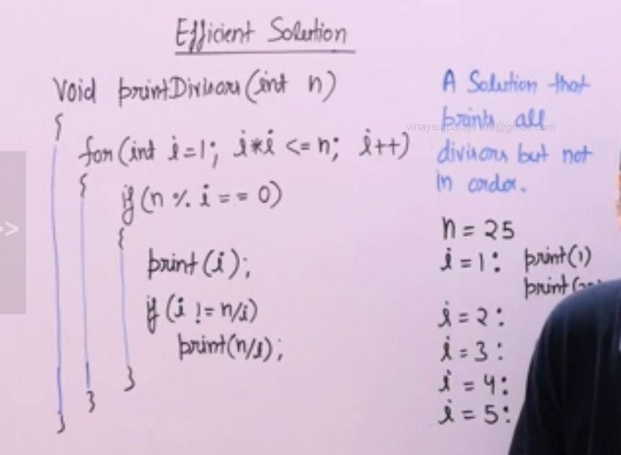

More efficient approach: requires theta(sqrt(n) time space and 1 auxiliary space

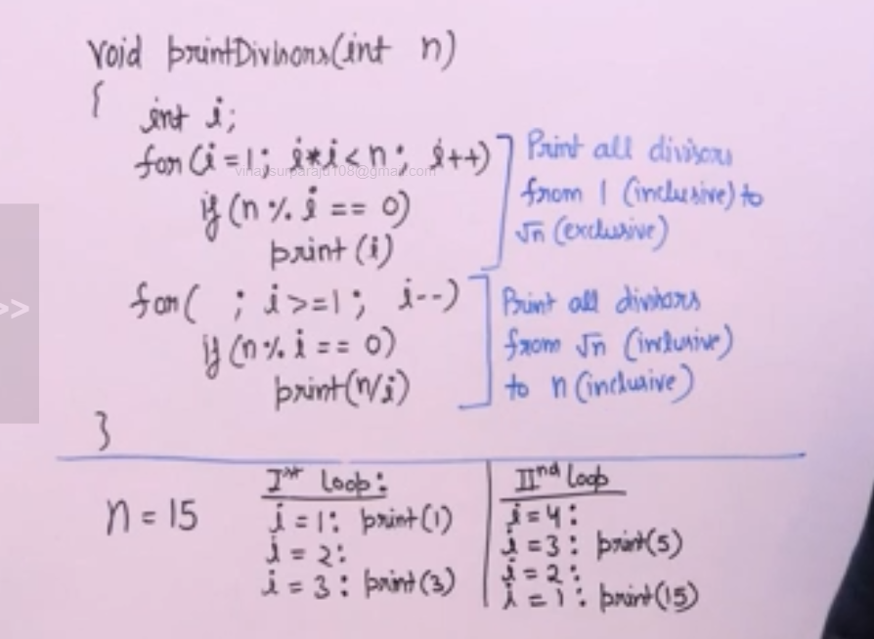

Sieve of Eratosthenes: Print all prime numbers smaller than n

Naïve sol: To loop and check if the input number is prime and then print the number

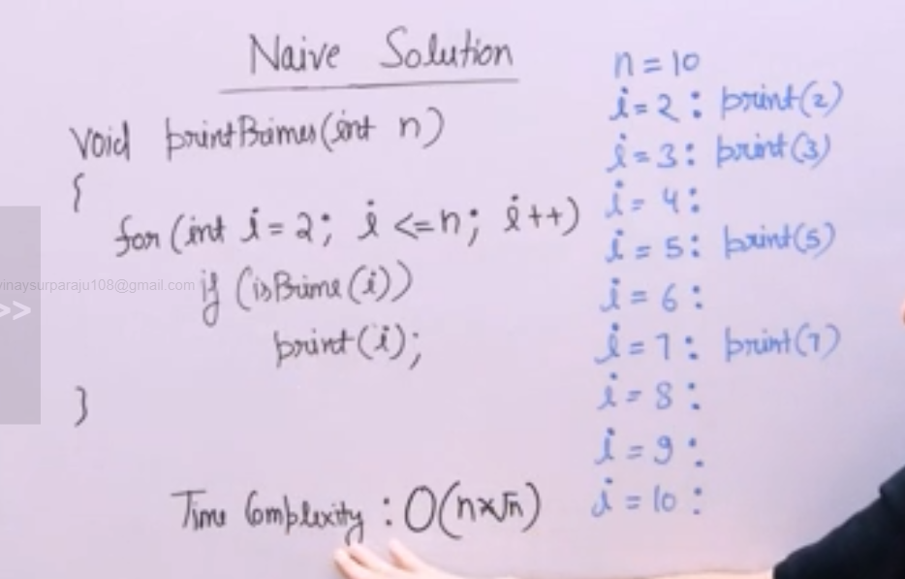

Sieve of Eratosthenes algorithm:

We declare the size of Boolean array as isPrime [N+1] and initialize the value as true and we mark the multiples of 2, 3 and 5 as false.The remaining numbers which are true are the prime numbers

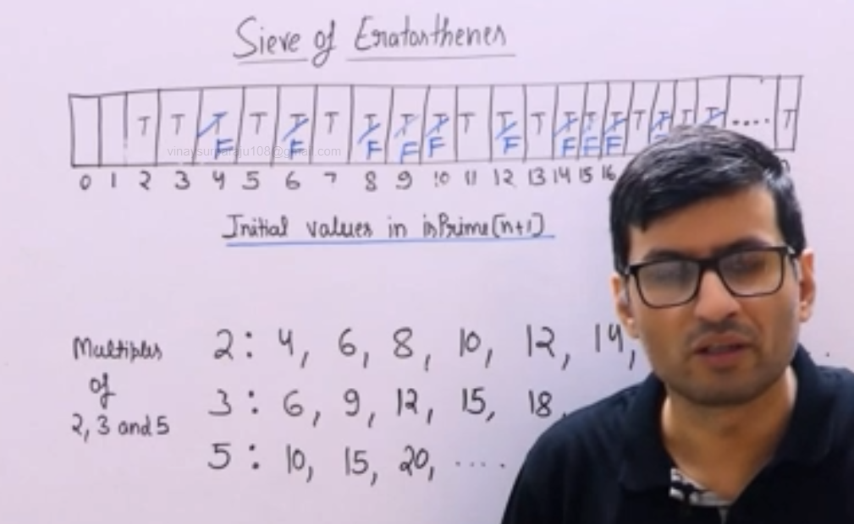

If you consider all divisors of a number, divisors always appear in pairs.The smaller of two numbers in every pair is always smaller than or equal to sqrt(n)

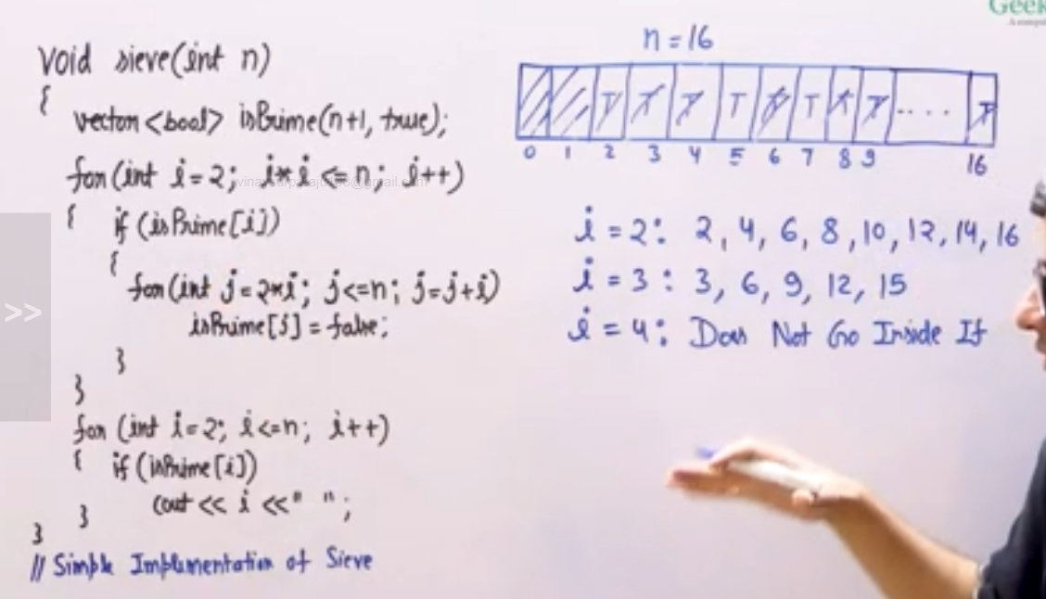

Optimized sol:

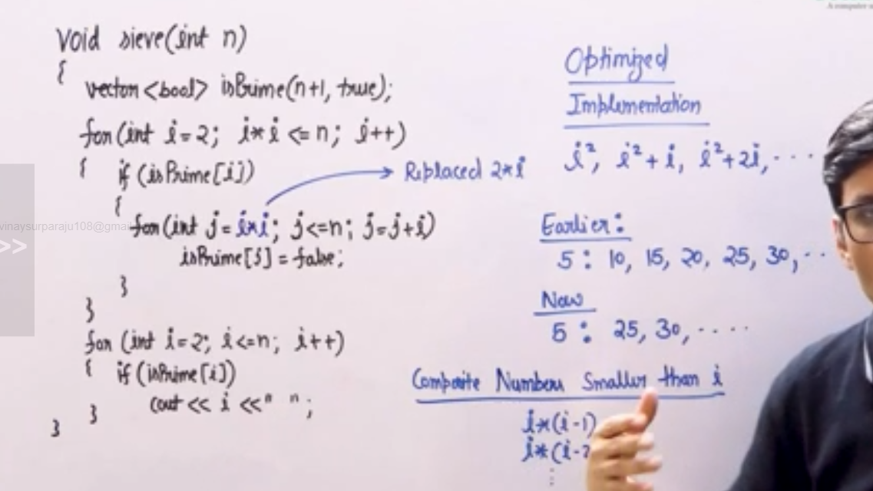

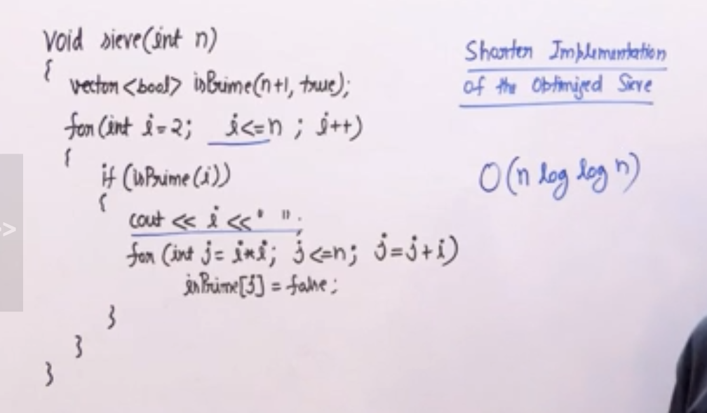

Computing power:

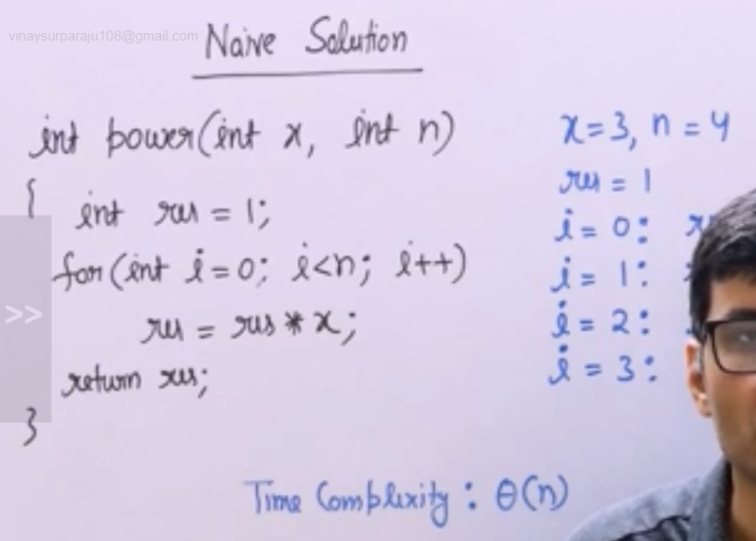

Efficient approach:

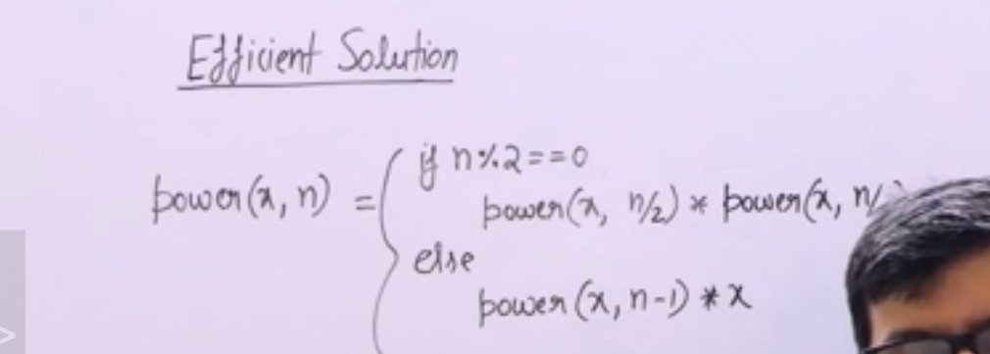

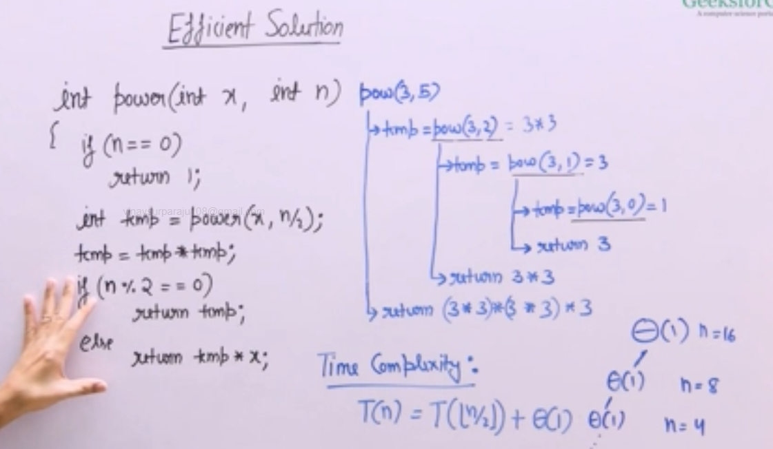

Iterative power:

In Binary representation, every number can be written as sum of powers of 2.

We can traverse through all bits of a number(from LSB to MSB) on O(logn).

